Lab guide 4:

Services

Q.1 Create a deployment using image quay.io/mayank123modi/simple-webapp named test3 After creating this expose it on ClusterIP type service by CLI method and check everything . create route
Q.2 create a deployment using quay.io/mayank123modi/myapache and expose it using NodePort type Service. And create route
Q.3 Expose a deployment that named test3 service name should be kubecluster and type is NodePort by YAML creation.and expose using route on URL.

Ans: 1

oc create deployment --image quay.io/mayank123modi/simple-webapp test3
oc expose deployment test3 --port 8080
oc get svc
oc describe svc test3
oc get pods -o wide

oc expose svc test3
oc get route
curl test3-mayank.apps.training.openshiftlab.xyz
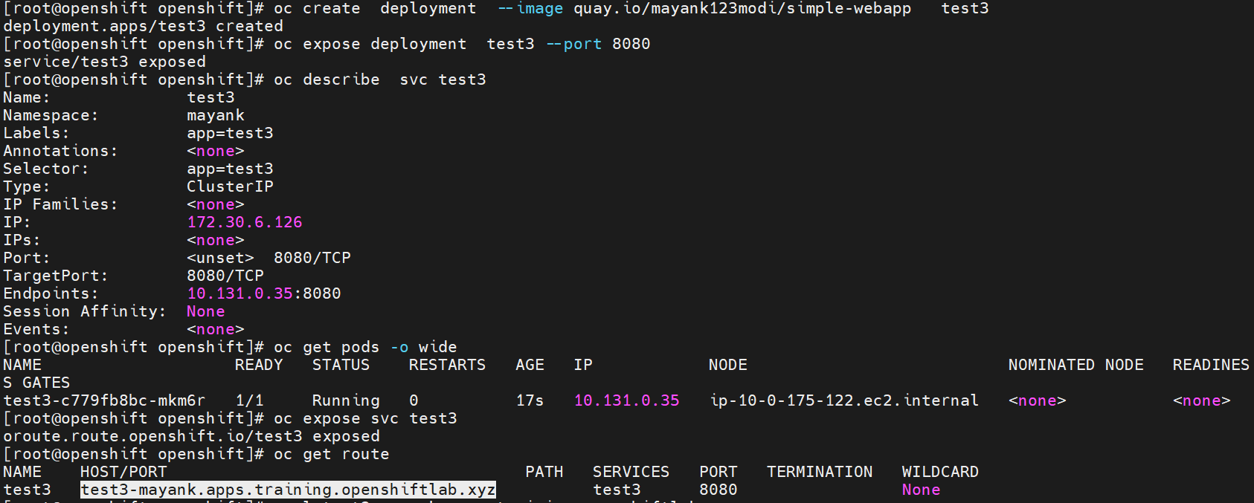

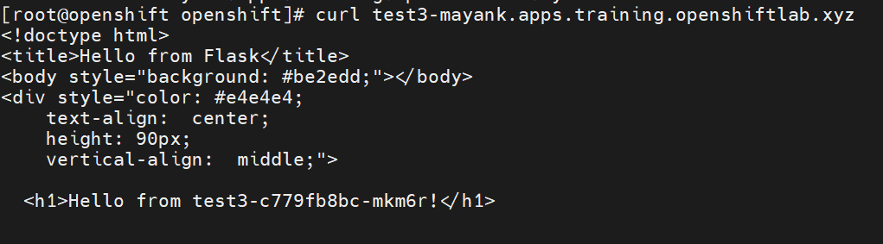

Ans: 2
oc create deployment --image quay.io/mayank123modi/myapache test4
oc expose deployment test4 --port 80 –type NodePort
oc get svc
oc describe svc test4
oc get pods -o wide
oc expose svc test4
oc get route
curl test4-mayank.apps.training.openshiftlab.xyz

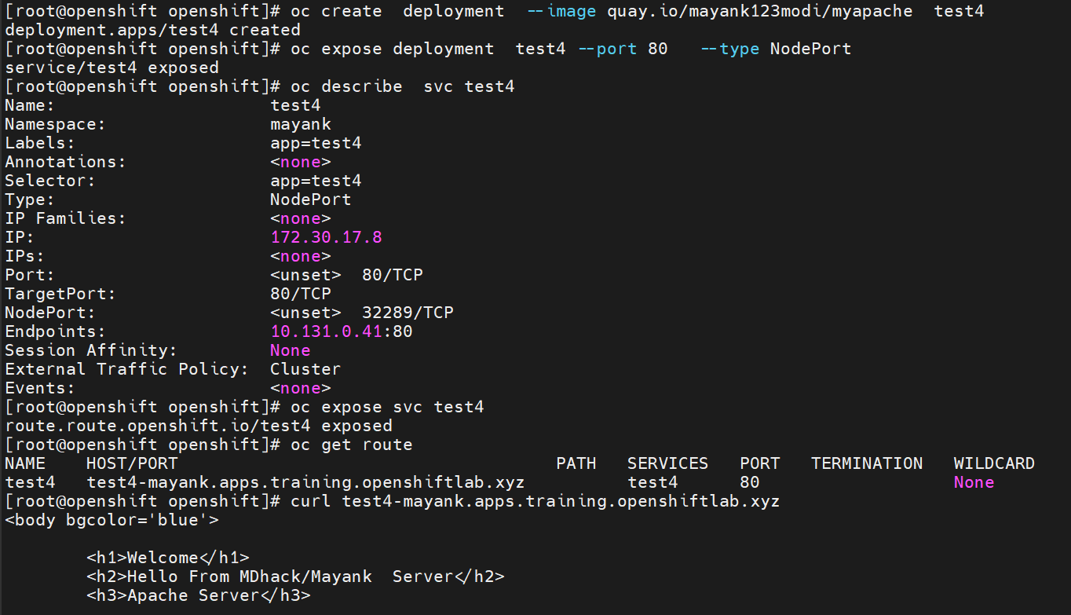

Ans: 3
oc create service nodeport kubecluster --tcp 8080 --dry-run -o yaml > svc.yaml
vim svc.yaml --- make sure selector are corrct
oc create -f svc.yaml
oc get svc
oc describe svc kubecluster
oc get pods -o wide
oc expose svc kubecluster
oc get route
curl kubecluster -mayank.apps.training.openshiftlab.xyz

Clean up your environment

oc delete all --all –force

